

***Hospital Management System For Mayo Clinic***

**Simplilearn CBAP Certification Project 2**

**Project Submitted by:** Ashwini Lanjewar

**Course**- PC-BA-CBAP

**Table of contents**

1. Introduction

1.1 Business Analysis Core Concept Model (BACCM)

* 1. Requirement Classification Schema (RCS)

1. Identify Stakeholders
2. Describe the proposed system flow
3. Write the In scope and Out of Scope Items for HMS
4. Scope of Hospital Management System (HMS) (Context Diagram)
5. Main features of HMS
6. Entity Relationship (ER) Diagram
7. Data Flow Diagram for HMS
8. Functional and Non-functional Requirements of HMS
9. Draw a Flow chart for the patient’s admission process
10. Draw Mock screen for Home page and Registration screen
11. **Introduction**
    1. **Business Analysis Core Concept Model (BACCM)**

Business Analysis Core Concept Model is a conceptual framework for business analysis. BACCM has 6 core concepts namely: Need, Change, Solution, Context, Value & Stakeholders.

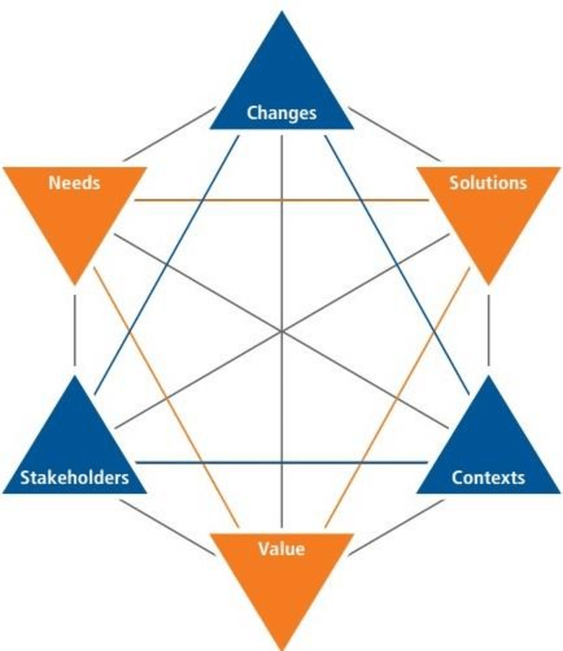

|  |  |
| --- | --- |
| NEED | * The clinic's facilities and size were expanding, making it challenging to manage the volume of paperwork. A hospital management system is required in order to properly manage all of the operations. |
| CHANGE | * From traditional process to an Agile Automated process of Hospital Management System for Mayo Clinic * The new system will assist Doctors, Nurses & other operating staff in maintaining better patient records while reducing operating expenses and hospital administration overhead. It will also improve internal and external communications between the hospital and its patients. * Use of system that can digitally store all the data and enable staff to work more effectively to replace all the paperwork and manual work. |
| SOLUTION | * To develop a hospital management system that simplifies the process for patients to register, schedule appointments and reminders, pay bills, get lab test results, bed availability, manage staff and insurance. * The data will be stored on cloud and thus eliminating the need of paperwork and manual efforts. |
| CONTEXT | * The current system is not effective enough to safely save all of the patient and internal hospital records, which is the context driving change that is caused by an expansion in hospital size and facilities |
| VALUE | * Reduce operating costs of the hospital * Provide reports to senior management for better decision-making * Saves patients’ time * Keeps patients’ medical records secure and stored in cloud * Keeps track of empty and filled beds in the hospital * Easy access to patient data * Reduces documentation in the hospital. |
| STAKEHOLDERS | External Stakeholder   * Supplier * Project Manager * Domain SME * Implementation SME * Operations team * Testers   Internal Stakeholder   * Insurance & Hospital staff * Lab Attendants * Doctors & Nurses * Patients * Pharmacy * Business Analyst |

**1.2 Requirements Classification Schema (RCS)**

* **Business requirements:** To develop a Hospital Management System (HMS) HMS is designed to store patients records, show availability of beds, manage patients’ billing, scheduling a doctor’s appointment, and will bring about coordination among the different departments.

Other requirements are:

* Reduce operating costs of the hospital.
* Provide reports to senior management for better decision-making.
* Save patients’ time.
* Keep patients’ medical records secure and stored in cloud.
* Keep track of empty and filled beds in the hospital.
* Easy access to patient data
* Reduce documentation in the hospital.

**Stakeholder requirements:**

* **Patients:** The patient will register themselves on the system and the system will record all their information and medical history.
* **Registration Staff:** The registration staff will give each registered patient a unique patient ID, which will be used by the patient throughout their stay in hospital.
* **Doctors and nurses:** They will use the system to access patient’s medical records and history at the time of providing medical diagnosis and care. They will provide prescription and tests(if required) from the HMS.
* **Laboratories and Radiation department:** The prescribed tests are received by the laboratory or radiation department directly. Once the tests are done, the reports will be uploaded into the HMS which can be again accessed by the doctors and patients.

**Solution requirements:**

* Functional requirements**:**
* **Database:** MySQL Database to be used since it is open source and free.
* **Operating System:** Shall be Windows 2016
* **Web-Based:** The system shall be a web-based application.
* Non - functional requirements**:**
* **Errors:** The system shall keep a log of all the errors
* **Availability**: The system shall be available all the time 24/7
* **Usability**: The screens should be self-explanatory and very user friendly. Management would not want employees not ordering from the system as they cannot understand the screens and data fields on screen

**Transition Requirement –** Transition from manual system to online system.

• Securely storing all existing info.

• Training for the new online system for all staff

1. **Stakeholders**

The different levels of stakeholder involvement for the creation and implementation of the Hospital management System project as described:

Project Manager

Regulators

Hospital Management

Business Analyst

Hospital Staff

Domain SME

Patients

Implementation SME

Sponsor

Tester

Supplier

Operational IT Support

**RACI Matrix**

RACI matrix is used here for identifying the responsibility of each stakeholder involved in the process:

* Responsible (R): The people who will perform the task's work.
* Accountable (A): The people who make the decisions and are ultimately responsible for the task's completion.
* Consulted (C): Stakeholder or group of stakeholders, who are in loop and are asked to provide an advice/suggestion/information about the task. It is a two- way communication
* Informed (I): Stakeholder or group of stakeholders is kept up-to-date about the task and its outcome. Here, the communication is one-way.

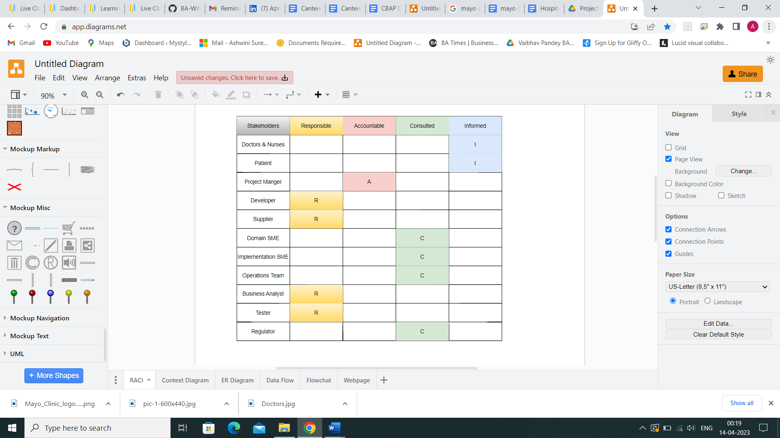

1. **Proposed Workflow Diagram**

Below is the described future workflow in swimlane method where the process users follow along with all the required hospital staff.

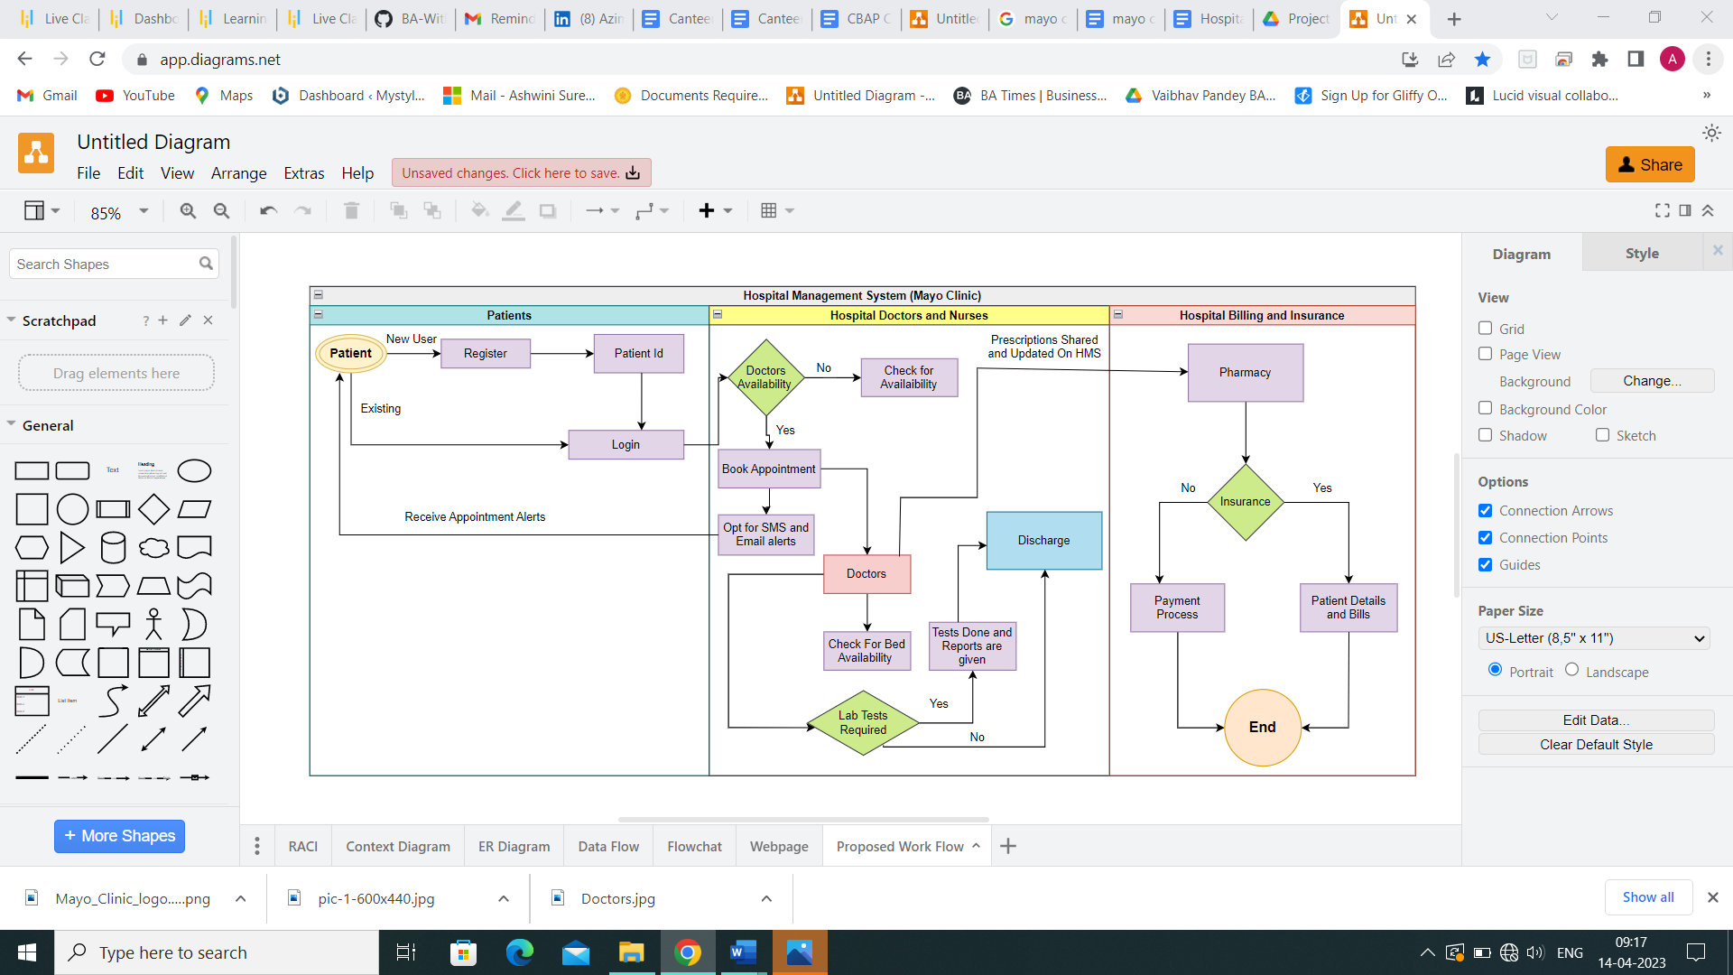

1. **In-scope and out-of-scope items for this software**

|  |  |
| --- | --- |
| **In Scope Requirements** | **Out Of Scope requirements** |
| Appointment Scheduling | Emergency department (ICU, Ventilators, Oxygen tanks, Beds etc.) |
| Appointment reminders | Hospital payroll management |
| Patient registration | Visitor log |
| Add / delete / update/ maintain patient’s record | Medical staff’s details |
| Order medical prescription |  |
| Order lab tests and lab test results |  |
| Patient admission |  |
| Bed occupancy management |  |
| Staff (nurses and ward boys) management |  |
| Report generation |  |
| Billing and Insurance |  |

1. **Context Diagram:**

Illustrated below is the context diagram across various actors that play important

role in maintaining, using and improvising various functionalities of the HMS for Mayo Clinic

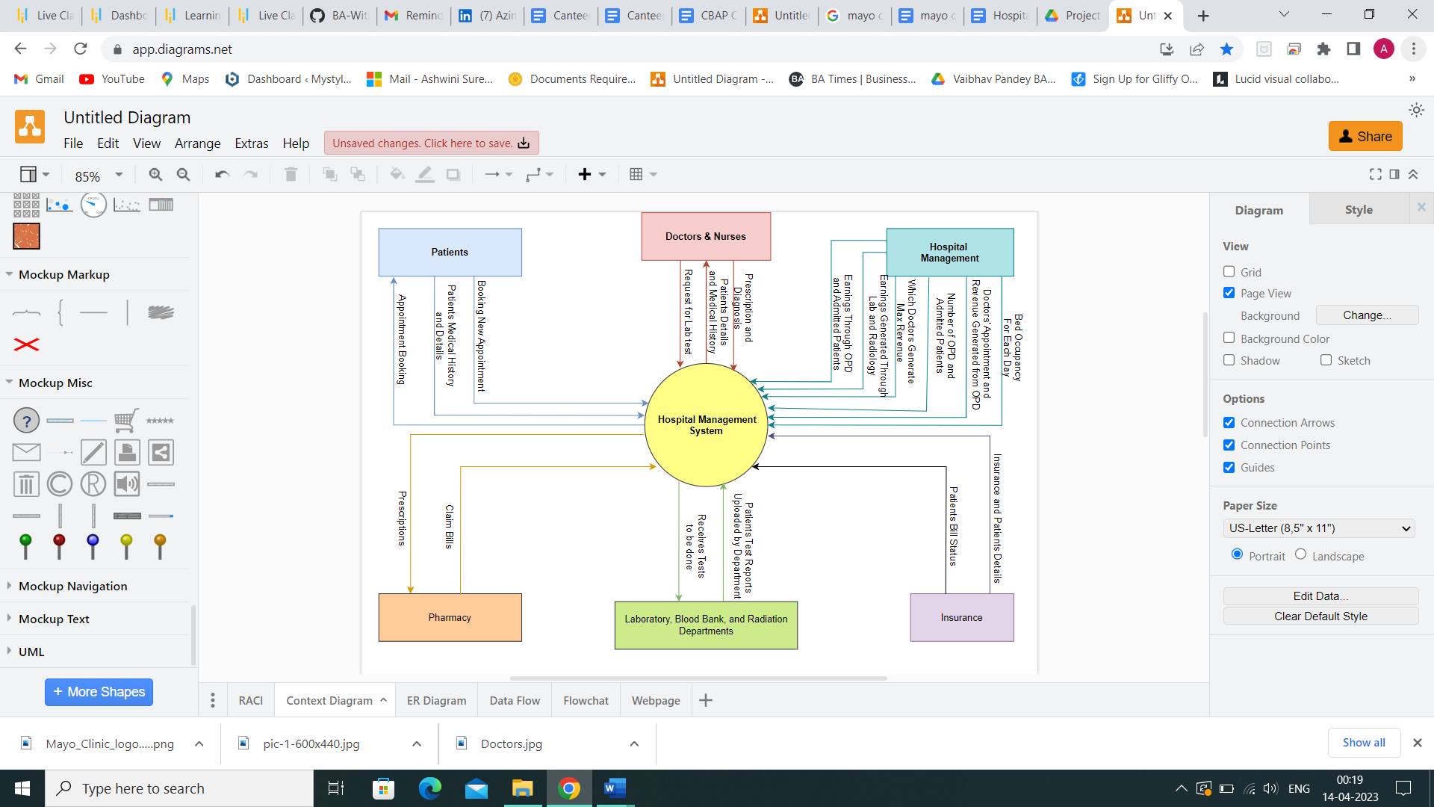

1. **Main features of HMS**
2. Patient registration and Login
3. Web-based Management System

* Must have MYSQL database and operate with windows 2016
* Must support volume of at least 500 users at a time
* Must response within 1 second
* Must be interactive and user friendly
* Must be working all the times

1. Appointment reminders via Email or SMS
2. Schedule/ Reschedule/ cancel appointment
3. Store patients’ medical details for anytime access
4. Staff allocation
5. Available and allocated bed details
6. Bill generation
7. Patient’s insurance details
8. Reports for Senior management

* Bed occupancy for each day
* Doctor’s appointment and revenue generation through OPDs
* Total number of OPD and admitted patients
* Which doctor generate maximum revenue
* Revenue generated from OPDs and admitted patients
* Revenue generated through lab and radiology

1. **ER Diagram**

An entity relationship diagram (ERD) shows the relationships of entity sets stored in a database.

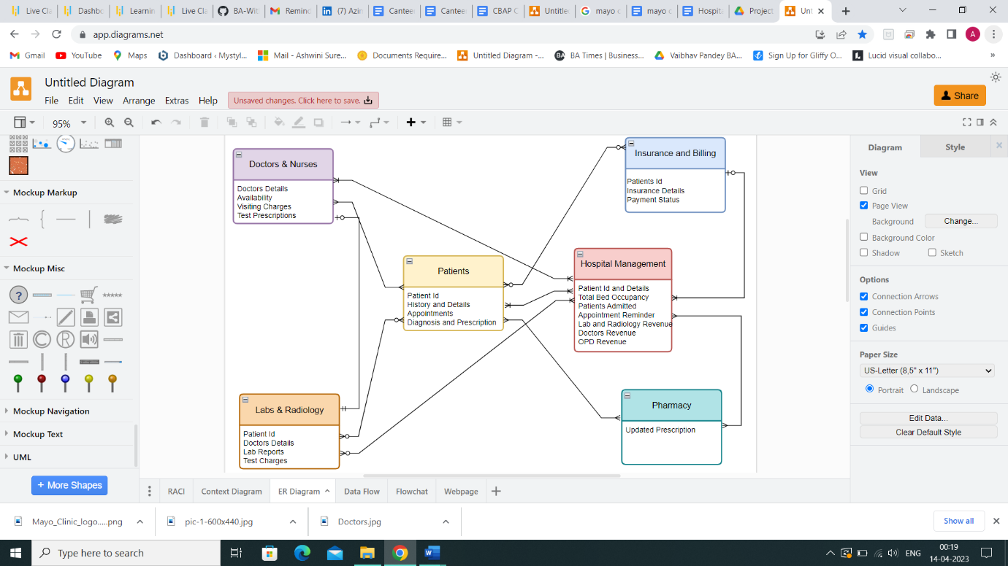

1. **Data Flow Diagram**

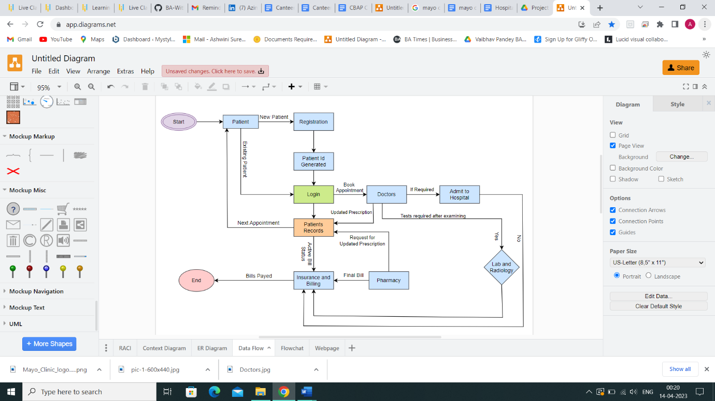

1. **Business Functional & Non Functional Requirements:**

Business Functional Requirements:

● Login and system requirements ( Doctors & Nurses )

* Allows only employees working in the hospital to have access to the system that have appropriate permissions.

● Patient Appointment Management:

* Upon successful login to the system , to display all the doctor scheduled to book an appointment at the patient convenience for the successful appointment confirmation.
* To be sent an alert one day prior to the day of appointment.

● Data Repository:

* The system should have access to all patients records with their unique id for the successful visit.
* Should have easy access to all patients after care.

● Lab & Radiology:

* Should have access to patient files for tests that are needed to be performed.
* Lab assistants to have access to upload reports
* Doctors to view the required patient reports.

● Billing and Insurance:

* Should have access to comprehensive bills upon patient discharge for either insurance processing or bill payment.
* Basic tracking of total bills paid or unpaid by current patients admitted in the hospital.

● Staff Management:

* The system will have a live record of all the active staff working in the hospital for effective staffing and scheduling.

● Reports:

* Bed occupancy for each day
* Doctors’ appointments and revenue generated through OPDs.
* Total number of OPD patients and admitted patients
* Which doctors generate the maximum revenue
* Total amount of earnings through OPD and admitted patients
* Total amount of earnings generated through laboratory and radiology.

Non-Functional Requirements:

● Availability: For ease of access, the system should always be accessible.

● Compatibility & Functionality: System should be user friendly screens to facilitate flow. All the departments should be able to use it freely without any glitches.

● Maintainability: As SQL is free and open source, it must be used for the databases.

● Reliability: Must be able to track and log all errors.

● Scalability: The system must be able to support at least 500 users or patients at once.

● Usability: The system must be able to support at least 500 users or patients at once.

● Compliance / Security: Must adhere to all state and federal laws governing patient care and records.

1. **Flow Chart**

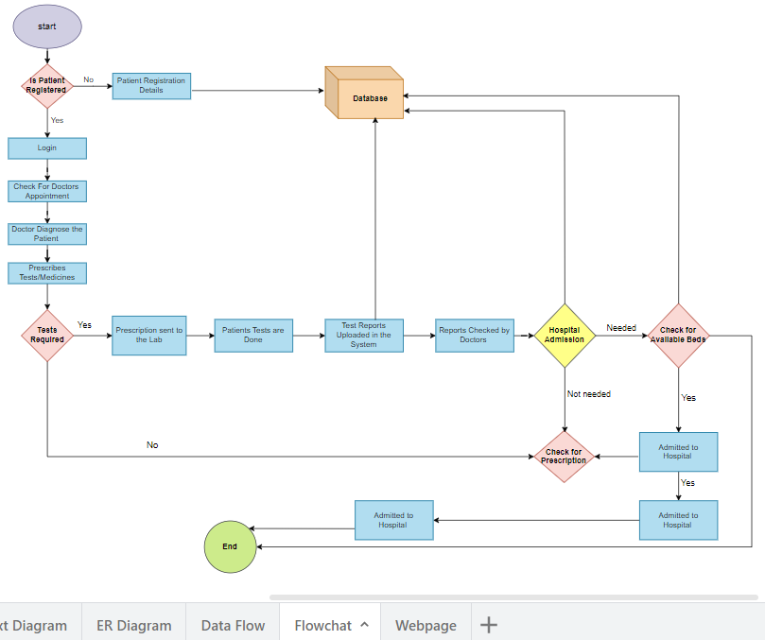

1. **Wireframe: Patients Login Page**

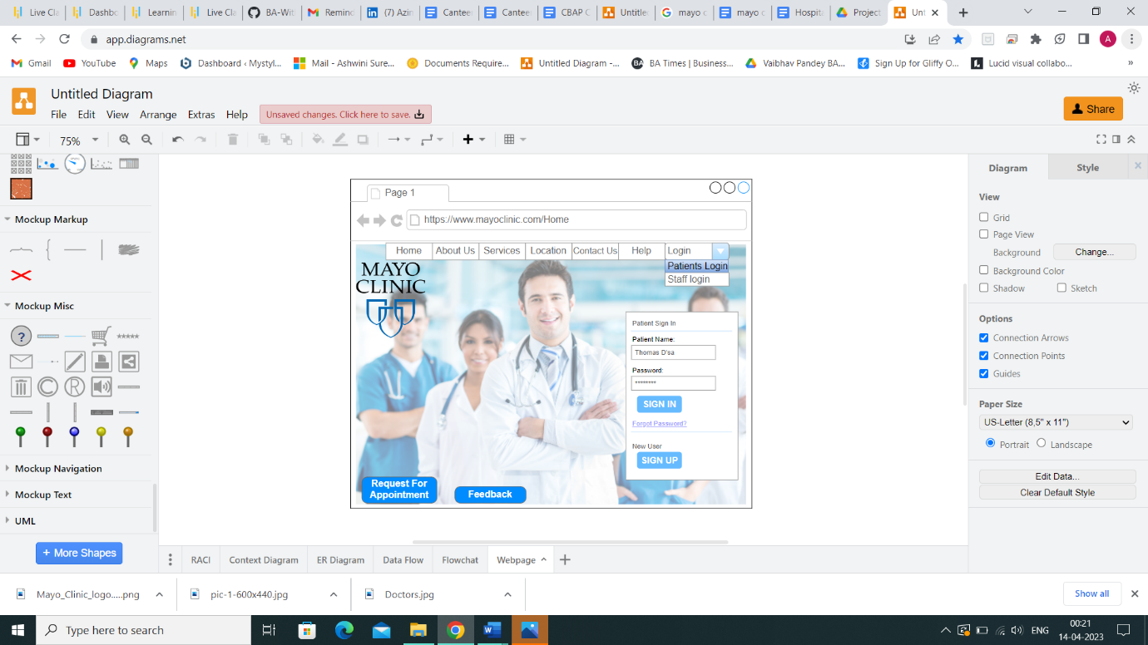

**Patients Registration Page -**

